Group Members:

Skeletal System



1. What are the major functions of the skeletal system?
2. List the components on the chart, and describe its function (job) in the chart below. Use your own words, and include: compact bone, spongey bone, ligaments, tendons, marrow, joints: hinge joint, ball and socket joint, pivot joint, gliding joint

|  |  |
| --- | --- |
| Component/Part | Job/Function |
|  |  |
|  |  |
|  |  |
|  |  |
|  |  |
|  |  |
|  |  |
|  |  |
|  |  |

List three fun or interesting facts about your system.



3.

Complete the diagrams. Use books or the internet to do this!

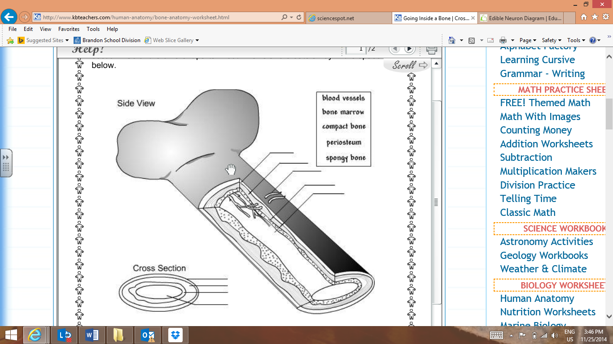 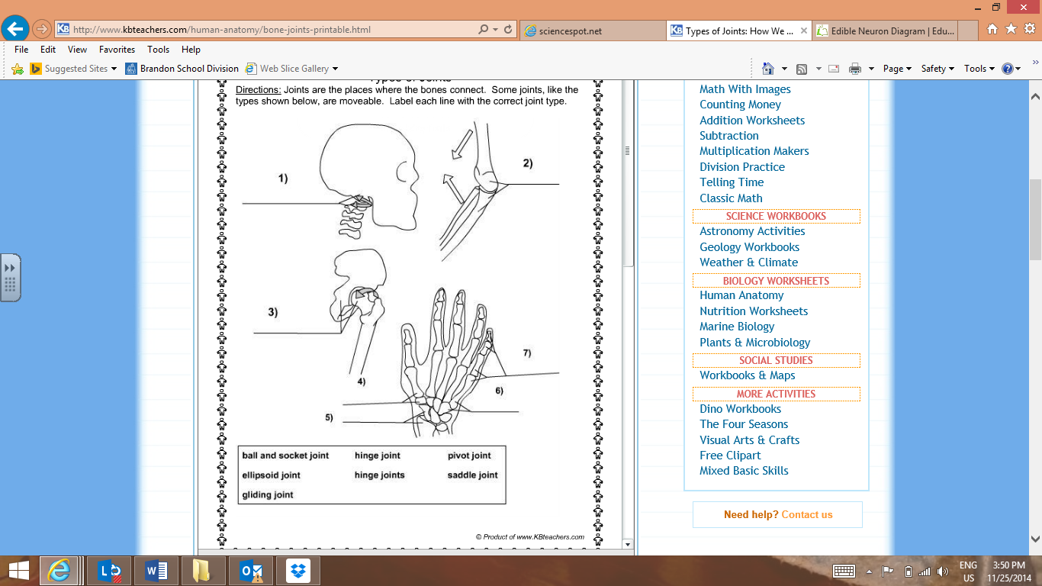

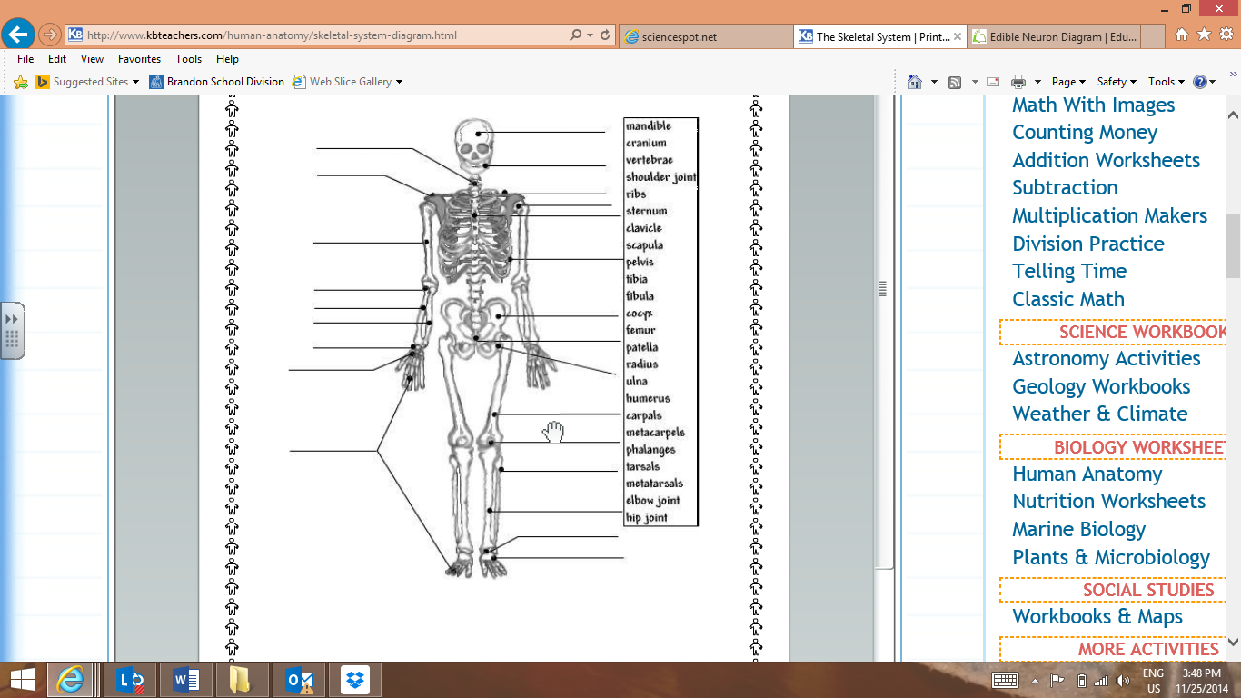

Describe how your system works with other systems in the body. You will need at least three examples!

Example 1

Example 2

Example 3

Sketch and label a diagram of the model you want to make for your system.

Materials Needed

Plan